Analysis on Handwritten Document Text to Identify Human Personality Characteristics by Using Preprocessing and Feature Extraction

Abstract

It is important that a company uses the right means to recruit employees with certain personal characteristics as needed. Nowadays, the techniques to respond to psychological tests on people’s characteristics have been widely understood by most job applicants, so that it is difficult to know their true personality. Graphology is a way to identify a person’s characteristics by analyzing the handwriting from the document text made by the applicant. The two types of text document of each applicant are obtained from people of different ages and different writing times. The methods of graphology used in this research for identifying the handwriting are preprocessing and feature extraction. The preprocessing method uses projection integrals, shear transformations, and template matching. While the feature extraction process applies 10 features, they are, margins, line spacing, space between words, size of writing, style, zone, direction of writing, slope of writing, width of writing and shape of the letter. The result of the experiment from five writers shows the accuracy of writing identification equals to 82%, while personality identification equals to 67,4%.

Keywords: Personal characters, Handwriting, Identification, Text document, Graphology

1. INTRODUCTION
The process of recruitment of employees in a company is the first step that companies do to find employees in accordance with the qualifications required. In the selection process, Human Resource Development plays a role to determine the employee in the right position. Psychological tests become one of the tools used in the recruitment process of prospective employees in order to get employees who have the potential appropriate for a field of work. Psychological tests are as a tool for knowing the personality of prospective employees. This helps Human Resource Development management find employees who have personality in accordance with the needs of the company.
Basically, to answer psychological tests, a technique known only to certain parties is used. However, today, the technique of psychological tests has been widely known due to the widespread book about psychological tests in various bookstores. It is a difficult matter for Human Resource Development to know the true personality of the prospective employee, because it is likely that the applicants will manipulate the psychological test answers. The inappropriateness of employee personality affects the quality of their works at the company. This is because human resources will become unproductive and the ability to work is not optimal. These impacts can make the company's goals less achievable.
Graphology reveals that personality and way of thinking can be demonstrated from handwriting. This is due to an unconscious act of writing activity [1-6]. At the time of the recruitment process, accurate job position analysis and employee counseling at work can be assisted by graphology [1-4][7]. The graphology test is able to know some hidden aspects of the applicant's personality during the recruitment process and is judged to be more useful than the interview. Graphology also states that the personality of a person such as feelings, fears, honesty, inquisitorial personality, work motivation and leadership, team coordination skills and so on can be expressed through handwriting [1-4][7].
In this research, we will build a system to know employee’s personality through handwriting according to graphology, which will be grouped based on positive nature and negative nature. We have modeled the proposed system, which will reveal the writer's personality based on positive nature and negative nature after the feature extraction process. Interview method is used as a process of clarifying the writer’s personality on the results of the system with the actual writer’s personality.

- RELATED WORKS
Researchers have previously conducted research to recognize a person's personality using handwriting [3][9-10]. They were conducted using different parameters.
The research conducted by Sri Widoretno, M. Sarosa, and Muhammad Aziz Muslim used the basis of integral projection method as the identification of writing with a description of the nature of the user based on each recognizable pattern as the final result [9]. Gray-scaling and thresholding methods are used as pre-processing. The segmentation includes segmentation of lines, segmentation of words, and segmentation of letters. Segmentation is done to find out the pattern of margin, slope, size and distance of space in the handwriting. Moreover, its feature extraction includes average size of height and width of characters, ascenders and descenders, and modeling strokes.
Dewi Mutamimah, in her research, used 4 features for the introduction of personal characters, such as font, zone, style and space [10]. This study uses the writing of data as much as one line by utilizing mobile technology on android operating system. In the personal characters’ description, the researcher performs a combination of all personality based on features, so the personal characters that appear are the whole between the negative and the positive. Experiments were performed on 24 posts from different people giving 100% results to find the writing zones using vertical and differential projection histograms, font size 95.83%, space of word with 91.66% success and writing styles having an accuracy higher than 95.83%.
The research of Kukuh Adi Prasetyo [11] is a continuation of Dewi Mutmainah's research. The features used in this research are the margins, the distance between lines, the direction of writing, the slope of writing, the width of writing, and the form of writing as a parameter of personal recognition. However, this study used two lines of data writing. The researcher's personality descriptor calculates the relationship matrix of the main properties of the answer from a graph of 36x36 graphologists to determine the corresponding personality, value 1 indicates the related property while number 0 indicates that they are unrelated. By experimenting 25 posts from different people gives the average success of the app to determine the ultimate personality 80% and the average success of the app to determine the personality detail 80%. This app is good enough to recognize a person's personality.
The current research also recognizes one's personality by utilizing graphology to know the personality using handwriting analysis as one's personality information between positive and negative qualities [9][11]. However, the research will be done using handwritten documents that have multiple lines, using 10 features. The features to be used are margins, line spacing, space between words, size of writing, style, zone, direction of writing, slope of writing, width of writing and shape of the letter as personality analyzes. In this study, personality introductions are proposed to assist Human Resource Recruitment in employee recruitment. Therefore, it is necessary to classify the personality of the company's demand for candidate personality and the selection process as determinants of employee acceptance.

3. ORIGINALITY
This research used a new approach to analyze personality by handwriting using documents consisting of multiple lines of writing. The handwritten document was obtained from several people’s handwriting. Each person gives handwritten results on a 210 mm × 297 mm sized paper of two sheets. The first and second sheets are distinguished by time. The handwriting is obtained from people of different ages between 20 to 30 years, regardless of their gender or socioeconomic status. The rules are considered based on the level of maturity. The ages of children and adolescents will tend to have fluctuating writing because this stage of age is a time when a person is still in the phase of searching for identity. Thus, the handwriting often changes. However, the adult writing will tend to remain.

4. SYSTEM DESIGN
This research will use features including margins, line spacing, space between words, size of writing, style, zone, direction of writing, slope of writing, width of writing and shape of the letter. This combined 4 features of Dewi Mutamimah’s research [10] and 6 features of Kukuh Adi Prasetyo’s research [11] into 10 features. This is an attempt to obtain higher accuracy in the personality analysis of previous studies.
To provide a global overview of the system to be built, the following is a design drawing process of personality recognition through handwriting.

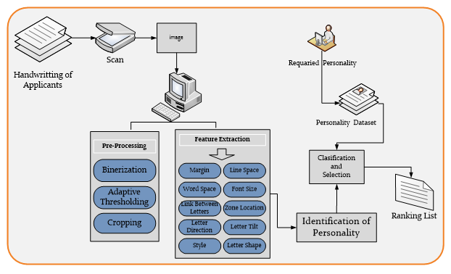
Figure 1. The System Design of our proposed research

- Data Collection
The data used are two types of data, personality data and handwriting data. Personality data is collected from graphology books taken based on margins, line spacing, space between words, size of writing, style, zone, direction of writing, slope of writing, width of writing and shape of the letter.
In addition to personality data collection, handwriting data were collected from different people from 20 to 30 years old on HVS paper which will be used for testing on the system.

- Preprocessing
The preprocessing stage consists of binarization and segmentation. Binarization changes the color of the image to a black and white image.
Segmentation performed on preprocessing is divided into 2 types. They are segmentation for writing area capture process, and segmentation for writing every line [9-11]. Preprocessing is the first step in data processing. The first step to do is binerization or color change of image [7] [12-13].

- Binerization
Binarization is the process of changing the color of the image into black and white images or 0 and 255 [8-11]. Binarization is done using the threshold value of the image to be in though. The image color is divided into two, i.e. black and white parts or images 0 and 1. The color division of the image is separated by the threshold value which determines if the pixel of the image is below the threshold value then the image pixel will be changed to 0 and if it exceeds the threshold value then the image pixel it will be changed to 255 [10-13]. The value used is the threshold value in general that 128 [10].

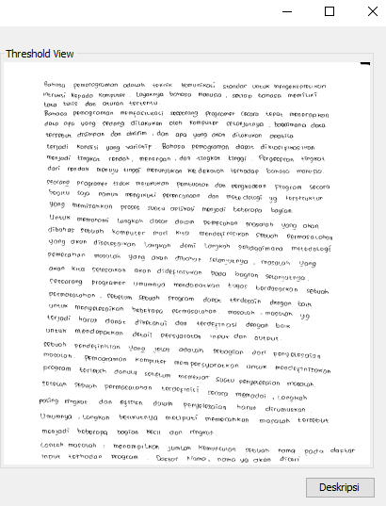
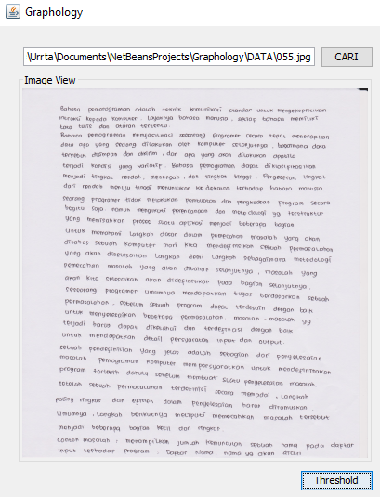
Figure 2. Original image Figure 3. Result of Thresholding

The above image is the result of binarization, colored images are changed to black and white images.

- Cropping Area
Cropping the writing area is an important object retrieval of an image [9-10]. The important object of this research is the complete area of writing. Cropping area in this research using vertical projection integral method and integral horizontal projection. Integral vertical projection is to get upper and lower bounds of writing area, and Integral horizontal projection is to get left and right boundaries of writing area [9-10].

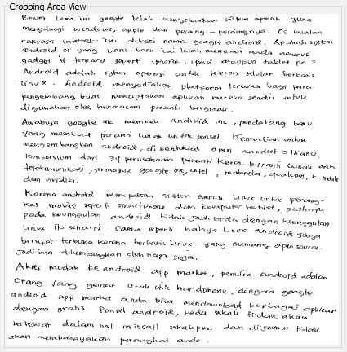
Figure 4. Cropping area result

The above image is the result of the cropping area process, the useless white area is removed.

- Cropping Baris
Cropping a line is the retrieval of a writing object in each line [9] [11]. The initial step is to calculate the integral vertical projection of the entire area. Then look for the starting and ending points on each line of writing, then take part in the starting point position with the endpoint limit.

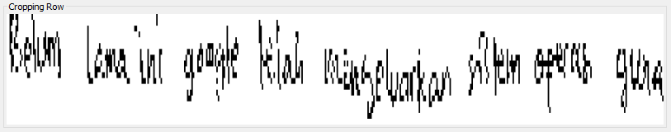
Figure 5. Cropping line result

- Fitur Ekstraksi
The extraction feature is the identification stage of writing . It is the process of recognizing the pattern of writing based on graphology [3-4] [7] [9-14]. To decide type of identification process, the research used a rule in accordance with the provisions in the graphology book changed according to logic to apply to the system.

- Margin Identification
The left margin and right margin have a specific meaning on each identification result [3-5] [7] [15] [17-18]. Identification of left and right margins is done by calculating the white value of the cut image in its top and bottom positions to the black limit. The white value is calculated until the first black point value is gained. The left margin is obtained by calculating the white value with the horizontal projection integral from the left. Moreover, the right margin is obtained by calculating the white value with the horizontal projection integral from the right direction.
The handwriting used in this research is written on A4 paper, which has a width of 21.0 cm. Formula used to convert to cm units is as follows [11]:

Margin in cm = ($\frac{x }{y}$) * 21.0 (1)

$x$ : Margins in pixels
$y$ : Paper width in pixels

Rules used for margin are if one's writing has a margin of 1 cm to 3 cm then the margin of writing is normal, if a person's writing has a margin> 3 cm then the margin of the text is wide and if a person's writing has a margin <1 cm then the margin of writing is narrow [11] [15].

- Line Spacing Identification
The distance between the lines is differentiated into wide, normal and narrow [4][7][9][15-18]. The distance between rows is obtained by calculating the vertical projection histogram and taking the white value, then calculating the amount of white space between the black dots and the row spacing of the text.

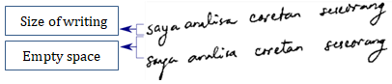
Figure 6. Illustration of spacing line [11]

The determination of the distance between lines is done by comparing the writing in the row with the spaces that become distance. If the result of comparison is <1.5 then the distance between the lines of writing is narrow, and if the result of comparison> 2 then the distance between the lines of writing is wide [11][15].

- Space between Words Identification
As the distance between lines, distances between words are differentiated into wide, normal and narrow [4][7][9][15-18]. The distance between words is done by counting the vertical projection histogram on every blank space on the writing.
If the spaces are more than 30% of the text heights in a row, then the spacebar of a person is wide. And if it is below 30% then the spaces are narrowly spaced [10].

- Size of Writing Identification
The size of the writing is the ratio of the area of the writing line to the writing area [4][7][9][18]. The identification of the size of the writing is calculated from the area of the writing and the area of writing of each line. After obtaining the area of each row then compared the two, between the total area of the image with the area of each row [10].
If the writing area is <7% then the writing is small. If the writing area is> 7% and less than 17% then the posts are grouped in normal letters. And if the writing area is> 17% then it is classified on uppercase size [10].

- Style of Writing Identification
Style of writing is divided into two types, they separated writing and conection writing [1-3][17]. The writing style is determined with a projection histogram to search for letters that are separated from the other letters.
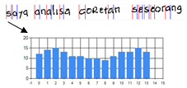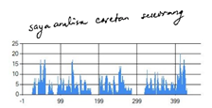
Figure 7. Illustration of separate [11] Figure 8. Illustration of connection [11]

According to the rule, if the letters are separated more than 6 each line then the writing model is a separate letter [8].

- Zone of Writing Identification
The writing body is the zone where the writing has the higest histogram and is the middle letter zone [3-4][6][10]. To search for body of writing, histogram projection and differential is used to find the two tops of the image or body of writing.
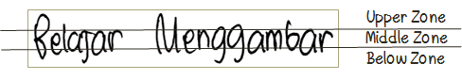

Figure 9. Illustration of zone [10]

Therefore, a rule is obtained; if the number of black dots in the upper zone> of the middle zone and the lower zone then the writing includes the upper zone, if the total black point value in the middle zone> of the upper and lower zone then the writing includes the middle zone, and if the number of points black in the lower zone> of the upper zone and the middle zone then the posts include the lower zone [10].

- Direction of Writing Identification
The direction of writing is divided into three types, upright writing, decreasing writing and flat writing [2][4][6][9][11][15][8]. The first step to get the writing direction is to take 1/3 of the beginning of the post and the third of the writing.
The beginning is to calculate the integral of the vertical projection of each of the first 1/3 and 1/3 of the end. Once the position is obtained, then the first 1/3 position and the final 1/3 position are compared.
Thus, if the initial 1/3 position is less than 1/3 of the end position then the writing is said to decrease. And if the first 1/3 position is more than 1/3 of the end position then the writing is said to be ascending [11].

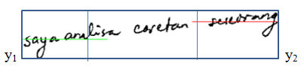

Figure 10. Illustration of direction [11]

Identifying the position of writing between ascending, descending or horizontal is done by giving a threshold value.

- Slope of Writing Identification
Handwriting generally has three types of slope, they are left tilt, right tilt, and erect [1-6][11][17]. The slope of the writing was obtained by finding the maximum value of the histogram integral horizontal projection of the original writings, the writings that positive shear transformation has been applied, and the writings that negative shear transformation has been applied [11][20].
It must first determine the value of m sufficient to make italic writing upright. Below is a picture illustration of the slope of writing.

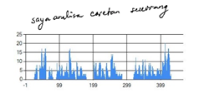

Figure 11. Horizontal Integral Projection of Original Handwriting [11]

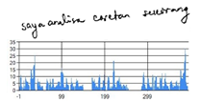
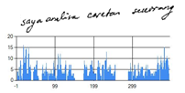

Figure 12. Shear Negative [11] Figure 13. Shear Positive [11]

After getting the maximum value of the horizontal integral projection of the original handwriting, handwriting which has applied positive shear transformation, and handwriting that has applied negative shear transformation, it is known to determine the slope of writing as follows [11]:
- Max value of positive shear transform > max value of original writing and max value of negative shear transform, slope of writing is to the right.
- Max value of negative shear transform > max value of original writing and max value of positive shear transform, slope of writing is to the left.
- Max value of positive shear transform and negative shear transform ≤ max value of original writing, the writing is upright.

- Width of Writing Identification
The width of the handwriting is distinguished by the narrow or narrowed writing style [1-3][11]. Cropping the writing is done to get the letter with threshold limit; this is done to anticipate writing with a continuous style. The determination of the writing widens or narrows uses the height and width of the first letter or symmetrical letter.
The height of the letter is obtained by calculating the vertical projection integral and the horizontal projection integral to calculate the width of the letter.
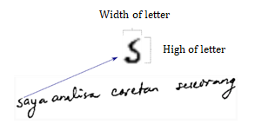
Figure 14. Illustration of width [11]

Width of handwriting has these rules; if the letter height is more than the width of the letter then the writing is narrow, and if the letter height is more than the width of the letter then the writing is wide.

- Shape of Letter Identification
The shape of the letters is distinguished into spherical and pointed. Different shapes can be seen in the letters "m" and "n" [1-3][11][17]. The determination of letters, conducted experiments using zero mean filtering or sum square difference [11]. Previously, 6 templates with size 13 pixels x 15 pixels have been prepared for filtering. The templates are upright round letter shape, rounded letters to the right, rounded letters obliquely to the left, upright taper letters, tapered lips to the right, tapered lops to the left.
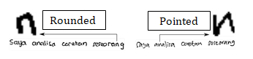
Figure 15. Examples of rounded and pointed letters [11]

Furthermore, zero mean filtering or sum square difference with those templates is done [20]. The purpose of this filtering is to find the shape of the letter. If in the writing found a round letter then the writing is using a round letter, and vice versa if found a pointed letter then the writing is using pointed letters. Determination of a pointed or rounded letter will be seen from the value generated by filtering on the template used.

5. EXPERIMENT AND ANALYSIS
This point discusses system performance. We analyzed 3 handwritings from different writers. We will see the system to finish processes and to give system performance. This experiment also compared the result of handwriting identification from system with the result of handwriting identification using graphology handbook tutorial. Then, the result of personality identification will be matched to the writer using interview method.
The result of matching personal characters, will be calculate using confusion matrix to prediction accuracy positive characteristics and negative characteristics [21-24]. The accuracy is the total number of predictions that were correct [21-22] :

$Accuracy= \frac{a+b}{a+b+c+d} x100\%$ (2)

- First Writer
The first handwriting that has been tested on the system gets 2 errors in identification. First, regarding the style of writing, the system states that the writing style is separated, where as according to the graphology, the writing style is identified as connected. Second, regarding the shape of letter, the system identified the shape of letter is rounded, while according to the graphology book the shape of letter is pointed. The compatibility of the system is 80% towards the first writer.

Table 1. Result of Feature Identification
 | System | Graphology Handbook
Margin | Left normal and Right normal | Left normal and Right normal
Line Spacing | Narrow | Narrow
Word Spacing | Wide | Wide
Size of Writing | Small | Small
Style of Writing | Separate | Connection
Zone | Middle | Middle
Direction of Writing | Flat Direction | Flat Direction
Slope of Writing | Flat | Flat
Width of Writing | Normal | Normal
Shape of Letter | Rounded | Pointed

Errors in the identification of style, either connected or separated might be caused by separate letters in a line of writing, with the number of more than predetermined or a thin letter connection so that the system reads noise.
The results of interviews with the first writer of 34 personal characters are positive and 29 negative personal characters by the system toward the parameters which indicates that, the positive characteristic of the first writer has a match of 70%, and the negative positive characteristic of the first writer has a 70% match.
The level of accuracy of the system to the first writer personal characters can be presented in table 2.

Table 2. Value of confusion matrix personality
Personality Identification |  | Interview
 |  | Positive | Negative
System | Positive | 24 | 10
 | Negative | 11 | 18

We can count the level of accuracy of first writer as follows:

$$Accuracy= \frac{24+18}{24+10+11+18} x100\%=67\%$$

The results of matching in the system to the writer is the accuracy of personal characters to first writer is 67%.

- Second Writer
The second handwriting that has been tested on the system gets 2 errors in identification. First, regarding line spacing, the system states that the line spacing is narrow, where as according to the graphology, the writing style is identified as normal. Second, regarding width of writing, the system identified the width of writing is widen, while according to the graphology book the width of writing is normal. The compatibility of the system is 80% towards the second writer.

Table 3. Result of Feature Identification
 | System | Graphology Handbook
Margin | Left narrow and right narrow | Left narrow and right narrow
Line Spacing | Narrow | Normal
Word Spacing | Wide | Wide
Size of Writing | Small | Small
Style of Writing | Separate | Separate
Zone | Middle | Middle
Direction of Writing | Flat Direction | Flat Direction
Slope of Writing | Flat | Flat
Width of Writing | Widen | Normal
Shape of Letter | Rounded | Rounded

The results of interviews with the second writer of 46 personal characters are positive and 36 negative personal characters by the system toward the parameters which indicates that, the positive characteristic of the second writer has a match of 80%, and the negative positive characteristic of second writer has a 78% match.
The level of accuracy of the system to the first writer personal characters can be presented in table 4.

Table 4. Value of Confusion Matrix Personality
Personality Identification |  | Interview
 |  | Positive | Negative
System | Positive | 36 | 10
 | Negative | 7 | 29

We can count the level of accuracy of second writer as follows:

$$Accuracy= \frac{36+29}{36+10+7+29} x100\%=79\%$$
.
The results of matching in the system to the writer is the accuracy of personal characters to second writer is 79%.

- Third Writer
The third handwriting that has been tested on the system gets 1 error in identification. The system states that size of writing is small, where as according to the graphology, the size of writing is normal. The compatibility of the system is 90% towards the third writer.

Table 5. Result of Feature Identification
 | System | Graphology Handbook
Margin | Left Normal dan Right Narrow | Left Normal dan Right Narrow
Line Spacing | Normal | Normal
Word Spacing | Wide | Wide
Size of Writing | Small | Normal
Style of Writing | Separate | Separate
Zone | Middle | Middle
Direction of Writing | Flat Direction | Flat Direction
Slope of Writing | Flat | Flat
Width of Writing | Normal | Normal
Shape of Letter | Rounded | Rounded

The results of interviews with the third writer of 50 personal characters are positive and 36 negative personal chracters by the system toward the parameters which indicates that, the positive characteristic of the third writer has a match of 78%, and the negative positive characteristic of third writer has a 78% match.
The level of accuracy of the system to the third writer personal characters can be presented in table 6.

Table 6. Value of Confusion Matrix Personality
Personality Identification |  | Interview
 |  | Positive | Negative
System | Positive | 37 | 13
 | Negative | 8 | 28

We can count the level of accuracy of third writer as follows:

$$Accuracy= \frac{37+28}{36+13+8+29} x100\%=76\%$$

The results of matching in the system to the writer is the accuracy of personal characters to third writer is 76%.

- Fourth Writer
The fourth handwriting that has been tested on the system gets 2 errors in identification. First, regarding size of writing, the system states that the size of writing is small, where as according to the graphology, the size of writing is identified as normal. Second, regarding width of writing, the system identified the width of writing is widen, while according to the graphology book the width of writing is normal. The compatibility of the system is 80% towards the second writer.

Table 7. Result of Feature Identification
 | System | Graphology Handbook
Margin | Left Normal dan Right Normal | Left Normal dan Right Normal
Line Spacing | Narrow | Narrow
Word Spacing | Normal | Normal
Size of Writing | Small | Normal
Style of Writing | Separate | Separate
Zone | Middle | Middle
Direction of Writing | Flat Direction | Flat Direction
Slope of Writing | Flat | Flat
Width of Writing | Widen | Normal
Shape of Letter | Rounded | Rounded

The results of interviews with the fourth writer of 54 personal characters are positive and 42 negative personal characters by the system toward the parameters which indicates that, the positive characteristic of the fourth writer has a match of 60%, and the negative positive characteristic of fourth writer has a 40% match.
The level of accuracy of the system to the fourth writer personal characters can be presented in table 8.

Table 8. Value of Confusion Matrix Personality
Personality Identification |  | Interview
 |  | Positive | Negative
System | Positive | 33 | 21
 | Negative | 25 | 17

We can count the level of accuracy of fourth writer as follows:

$$Accuracy= \frac{33+17}{33+21+25+17} x100\%=50\%$$

The results of matching in the system to the writer is the accuracy of personal characters to fourth writer is 50%.

- Fifth Writer
The fifth handwriting that has been tested on the system gets 2 errors in identification. First, regarding line spacing, the system states that the line spacing is narrow, where as according to the graphology, the line spacing is identified as normal. Second, regarding shape of letter, the system identified the shape of letter is pointed, while according to the graphology book the shape of letter is rounded. The compatibility of the system is 80% towards the fifth writer.

Table 9. Result of Feature Identification
 | System | Graphology Handbook
Margin | Left normal dan Right normal | Left normal dan Right normal
Line Spacing | Narrow | Normal
Word Spacing | Narrow | Narrow
Size of Writing | Small | Small
Style of Writing | Separate | Separate
Zone | Middle | Middle
Direction of Writing | Flat Direction | Flat Direction
Slope of Writing | Flat | Flat
Width of Writing | Narrow | Narrow
Shape of Letter | Pointed | Rounded

The results of interviews with the fourth writer of 53 personal characters are positive and 45 negative personal characters by the system toward the parameters which indicates that, the positive characteristic of the fourth writer has a match of 89%, and the negative positive characteristic of fourth writer has a 38% match.
The level of accuracy of the system to the fifth writer personal characters can be presented in table 10.

Table 10. Value of Confusion Matrix Personality
Personality Identification |  | Interview
 |  | Positive | Negative
System | Positive | 47 | 6
 | Negative | 28 | 17

We can count the level of accuracy of fourth writer as follows:

$$Accuracy= \frac{47+17}{47+6+28+17} x100\%=65\%$$

The results of matching in the system to the writer is the accuracy of personal characters to fifth writer is 65%.

- CONCLUCION
The testing of five different writers also got different accuracy level on each writer. In the first writer, the level of accuracy in writing identification is 80%. While in the identification of the personality level of compatibility is 67% of the positive and negative. In the second writer, the level of accuracy in writing identification is 80%. While in the identification of the personality level of compatibility is 79% to the positive and negative. In the third writer, the level of accuracy in writing identification is 90%. While in the identification of the personality level of compatibility is 76% to the positive and negative. In the fourth writer, the level of accuracy in writing identification is 80%. While in the identification of the personality level of compatibility is 50% to the positive and negative. In the fifth writer, the level of accuracy in writing identification is 80%. While in the identification of the personality level of compatibility is 65% to the positive and negative.
The result of the experiment from five writers shows the accuracy of writing identification equals to 82%, while personality identification equals to 67,4%. It can be concluded that the system that has been built is able to recognize a person's personality using handwriting based on graphology science.

Acknowledgements
We would like to thank all parties who have been willing to give some handwritings to be used as the data in our research.

REFERENCES
[1] Septa Dwikardana, Partical Handbook of Graphology, PT Kanisius(Yogyakarta), Ed.1, pp.18-15, 2014.
[2] Dwi Sunar Prasetyono, Bedah Lengkap Grafologi Membaca Kepribadian Orang Lewat Tulisan Tangannya, DIVA Press (Yogyakarta),Ed.1, pp.79-175, 2012
[3] Ricard Coll, Alicia Fornes, and Josep Llados, Graphological Analysis of Handwritten Text Documents for Human Resources Recruitment, IEEE International Conference on Document Analysis and Recognition, DOI 10.1109/ICDAR.2009.213, No.10, pp.1081-1085, 2009.
[4] Somayeh Hashemi, Behrouz Vaseghi, and Fatemeh Torgheh, Graphology for Farsi Handwriting Using Image Processing Techniques, IOSR Journal of Electronics and Communication Engineering (IOSR-JECE), Vol.10, pp.01-07, No. 1, pp.01-07, 2015.
[5] Champa H N, and K R Ananda Kumar, Automated Human Behavior Prediction through Handwriting Analysis, IEEE International Conference on Integrated Intelligent Computing, DOI 10.1109/ICIIC.2010.29, No.1, pp.161-165, 2010.
[6] Parmeet Kaur Grewal, and Deepak Prashar, Behavior Prediction Through Handwriting Analysis. IJCST, Vol.3, No.2, pp.520-523, 2012
[7] Behnam Fallah, and Hassan Khotanlou, Identify Human Personality Parameters Based On Handwriting Using Neural Network, International Conference on Artificial Intelligence and Robotics (IRANOPEN), 978-1-5090-2169-7/16, pp.120-126, 2016.
[8] Nurul Ilmi, Tjokorda Agung Budi W, and Kurniawan Nur R, Handwriting Digit Recognition using Local Binary Pattern Variance and K-Nearest Neighbor Classification, International Conference on Information and Communication Technologies (ICoICT) ISBN: 978-1-4673-9879-4 (c) 2016 IEEE, 978-1-4673-9879-4, Vol.4, pp. 01-05, 2016.
[9] Sri Widoretno, M Sarosa, and Muhammad Aziz Muslim, Implementasi Pengenalan Karakter Seseorang Berdasarkan Pola Tulisan Tangan, Jurnal EECCIS, Vol.7, No.2, pp.96-101, 2013.
[10] Dewi Mutamimah, Pengenalan Kepribadian Orang Menggunakan Tulisan Tangan (Grafologi), D4 Final Project, EEPIS (Surabaya), 2015.
[11] Kukuh Adi Prasetyo, Aplikasi Mobile Pengenalan Kepribadian Orang Menggunakan Grafologi, D4 Final Project, EEPIS (Surabaya), 2017.
[12] Somaya Alma adeed, Colin Higgens, and Dave Elliman, Recognition of Off-Line Handwritten Arabic Words Using Hidden Markov Model Approach, IEEE, 1051-4651/02, pp.01-04, 2002.
[13] Gaurav Jain, Jason Ko, Handwritten Digits Recognition, Project Report , University of Toronto, 2008.
[14] Anita Ahmad Kasim, Retantyo Wardoyo and Agus Harjoko, Feature Extraction Methods for Batik Pattern Recognition: A Review, AIP Conference Proceedings Advances of Science and Technology for Society, American, pp.070008-1 - 070008-8, 2016.
[15] Nydia Amelinda Putri, Gelar Budiman, S.T., M.T. and Yuli Sun Hariyani, S.T.,M.T., Analisis Dan Implementasi Identifikasi Kepribadian Melalui Tulisan Tangan Pada Sistem Operasi Android Berdasarkan Pengolahan Citra, pp.1-8, 2016.
[16] Leonid A. Mironovsky, Alexander V. Nikitin, Nina N. Reshetnikova and Nikolay V. Soloviev, Graphological Analysis and Identification of Handwritten Texts, Springer International Publishing, 978-3-319-67994-5_2, No.4, pp.11-36, 2018.
[17] Ondˇrej Rohl´ık, Handwritten Text Analysis, Thesis, University Of West Bohemia In Pilsen, 2003.
[18] Behnam Fallah and Hassan Khotanlou, Detecting features of human personality based on handwriting using learning algorithms, ACSIJ Advances in Computer Science: an International Journal, Vol. 4, No.18, pp.31-37, 2015.
[19] Listiana MP Dewi, Hadi Prayitno, Hendri Sopryadi, and Rachmansyah, Aplikasi Sistem Pakar Analisis Tulisan Tangan (Grafologi) Menggunakan Algoritma Fuzzy Logic Berbasis Android, Skripsi, STMIK GI MDP, 2012.
[20] Eko Prasetyo, Pengolahan Citra Digital Dan Aplikasinya Menggunakan Matlab, Penerit ANDI (Yogyakarta), Ed.1, 2011.
[21] Sofia Visa, Brian Ramsay, Anca Ralescu, and Esther van der Knaap, Confusion Matrix-basedature Selection, Computer Science Department College of Wooster Wooster, 2011.
[22] A. K. Santra and C. Josephine Christy, Genetic Algorithm and Confusion Matrix for Document Clustering, IJCSI International Journal of Computer Science Issues, Vol. 9, No 2, pp.322-327, January 2012
[23] Cinthia O.A. Freitas1, João M. de Carvalho2, José Josemar Oliveira Jr2, Simone B.K. Aires3, and Robert Sabourin, Confusion Matrix Disagreement for Multiple Classifiers, Pontificia Universidade Católica do Paraná, 2008.
[24] Dirk B. Walther, Using Confusion Matrices to Estimate Mutual Information between Two Categorical Measurements, International Workshop on Pattern Recognition in Neuroimaging, DOI 10.1109/PRNI.2013.63, No.3, pp.220-224, 2013.

